HeapSort

#define TAMANHO 50000

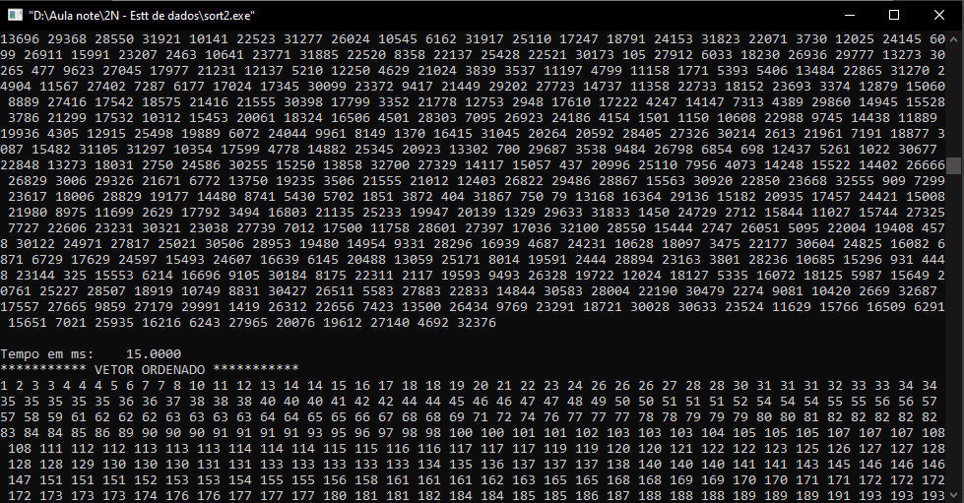

#define TAMANHO 100000

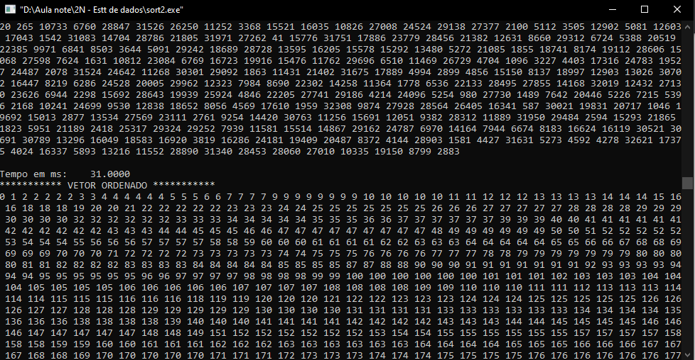

<https://www.youtube.com/watch?v=zSYOMJ1E52A&ab_channel=Programa%C3%A7%C3%A3oDescomplicadaLinguagemC>

####MERGE SORT !!!!!!!!!!!################

50000

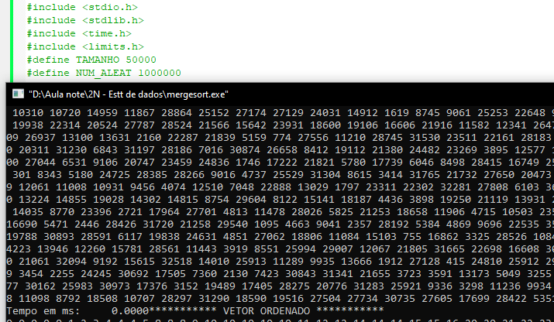

100000

